Iowa State University



Ecology, Evolution, and Organismal Biology

Dear Journal of Biological Education Editor: September 16, 2019

We are submitting a manuscript for consideration for publication in the Journal of Biological Education, titled “Using light stable isotopes to assess stream food web ecology in a general ecology laboratory course.” This article presents a case report from a Western Colorado University (Gunnison, CO, USA) ecology course for undergraduates. We detail an innovative experiential learning method for teaching food web ecology using stable isotope analysis of aquatic organisms and data analysis in the open source statistical software R.

We present all necessary field, laboratory, and data analysis protocols for teaching an aquatic food web module and suggest a set of six student learning outcomes. We demonstrate that all six are achievable using our methods, and evaluate student success in each. Outcomes include proficiency in field sampling of aquatic organisms using a variety of common techniques; classification of organisms to biological order; trophic level designations of organisms; safe laboratory practices in preparation of material for isotopic analysis; graphing and analysis of isotopic data using notebooks in the open source statistical software R; and communication of findings via scientific report (lab report). Students participating in this module achieved high levels of success in all six outcomes. In addition, we provide data and R notebooks that instructors can use to teach just the analysis portion, if desired, or modify for use with their own class datasets. We also provide an advanced R notebook exercise for instructors who wish to teach Bayesian isotope mixing models. Materials lists and a budget are included for planning purposes.

The manuscript contains five color figures and one grayscale figure. We wish to include color figures in the online version of the manuscript and grayscale only in the print version, should it be accepted for publication. Figure 2 shows pictures of students participating in field sampling of aquatic organisms. Western Colorado University students sign waivers to allow their images to be used. However, we have taken care to choose images which do not clearly show the faces of students out of respect for their privacy.

Thank you for consideration of this manuscript for publication in Journal of Biological Education. None of the authors have any financial or non-financial competing interests. Please do not hesitate to contact me should you require further information.

Sincerely,

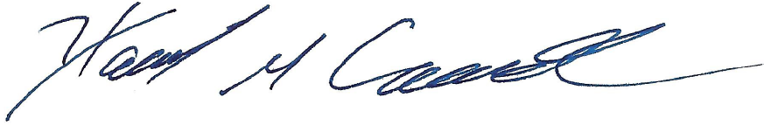

Hannah M. Carroll, PhD Candidate

Department of Ecology, Evolution, and Organismal Biology

2200 Osborn Drive

251 Bessey Hall

Iowa State University Phone: 1-515-991-4058 (mobile)

Ames, Iowa 50011 Email: [hannah.carroll@paleoeco.org](mailto:hannah.carroll@paleoeco.org)